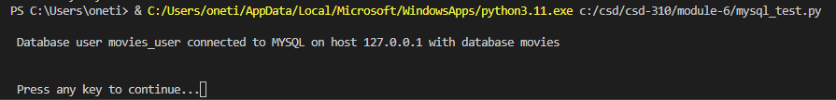

https://github.com/onetimesomeday